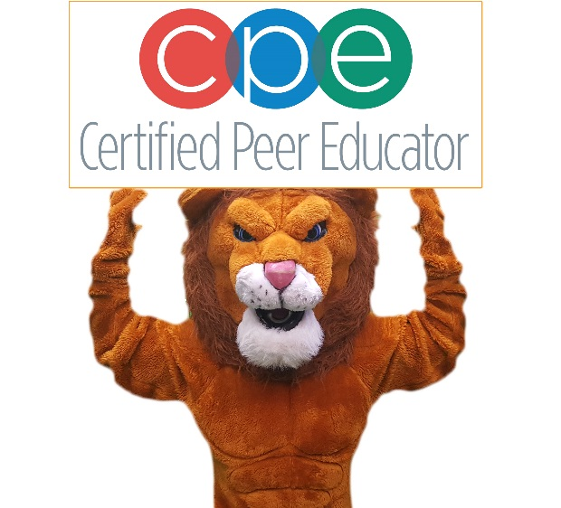
Certified Peer Educator Expectations

To qualify as a Certified Peer Educator and to maintain your status, you commit to the following:
- Thoroughly complete the application process, including a personal interview
- Successfully complete of all learning modules of the two-day training on April 24-25, 2023.
- Pass the national certification examination of NASPA. This is an online examination.
- Achieve academically. A CPE who earns an F or multiple D’s on a quarter report card will be placed on probation and may be removed from the program if academic performance does not improve.
- Serve as a positive role model for healthy lifestyle choices
- Refrain from illegal activities and illegal drug use
- Insure that your social media profiles and posts reflect positive health and leadership behaviors
- Attend ongoing CPE training offered monthly during ELB and/or Lion Time
- Lend ideas, skills, and talents to research, develop, and implement wellness/leadership programs and activities. These programs will be scheduled in advance during ELB, Lion Time, and occasionally after school

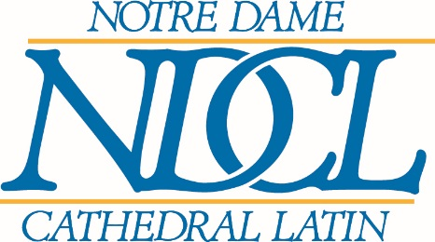

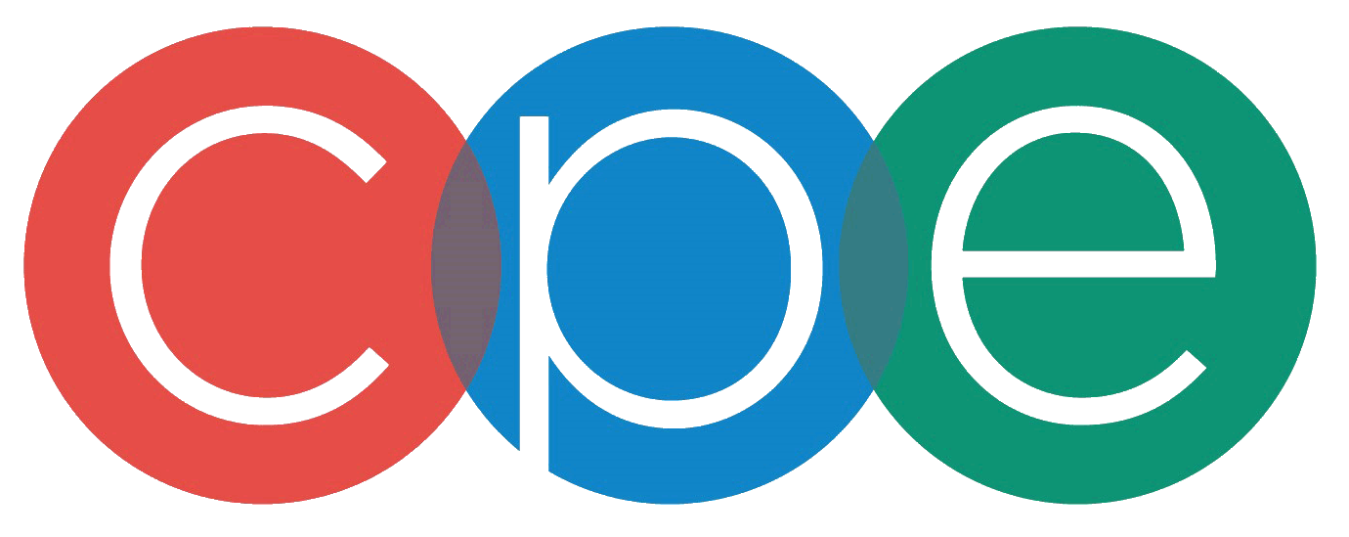
Certified Peer Educator Application

This form is available online: www.ndcl.info/CPE.docx

Please download it so that you can submit a neatly typewritten application by Monday, March 27, 2023, at 3:00 PM. You should submit your application to Mr. DeMichele.

Before completing this application, please be sure to complete the Teen Wellness Assessment. Although you have a hard copy, the assessment is also available online: www.ndcl.info/TWA.pdf

Your name: Click or tap here to enter text.

Are you enrolled in an ELB this semester? Choose an item. If YES, which block: Choose an item.

- Which dimensions of the Wellness Assessment are particular strengths for you?
Click or tap here to enter text.

- Which wellness dimensions do you seek to improve personally?
Click or tap here to enter text.

- What are some common student attitudes or issues related to wellness that you would like to influence or challenge as a Certified Peer Educator? In other words, what would you like to make better?
Click or tap here to enter text.

- In your opinion, what is—or ought to be—the biggest wellness concern for students at NDCL? Choose only one.
Click or tap here to enter text.

- Individual initiative is a key characteristic of a Certified Peer Educator. Describe a situation in which you took initiative and assumed responsibility to get something done.
Click or tap here to enter text.

- When you are in a group, what role do you usually play?
Click or tap here to enter text.

- Describe the most constructive criticism you ever received and how you responded to it.
Click or tap here to enter text.
- Please list all of your extracurricular, athletic, work, and other personal responsibilities:
Click or tap here to enter text.

COMMITMENT STATEMENT:
I have read and understand the expectations of a Certified Peer Educator. By signing below, I commit myself to developing and exemplifying positive leadership qualities in order to live the truth in love as I make a positive difference in the NDCL community and the university community to which I will one day belong.

_________________________________________________________ Date: Click or tap to enter a date.
Signature

